CONFIGURING REPORT PROPERTIES

- General
- Catching
- Formatting
- Font mapping
- Currency format

GENERAL

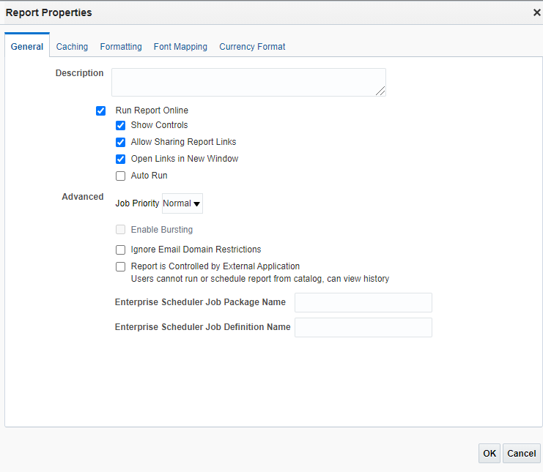
- Description :
To display with the report in catalog.
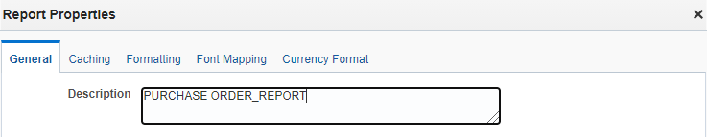
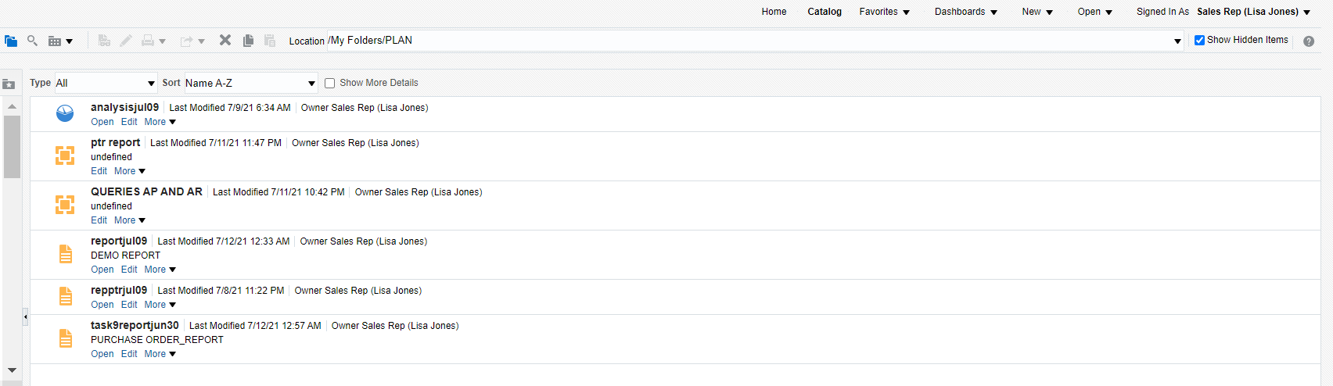
Click catalog to view description below report name.
Run report online: User can’t view report online.
- Show controls:
View report->before disable show control.
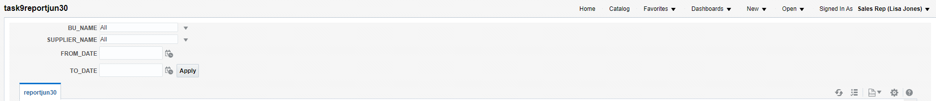

After enabled final out:
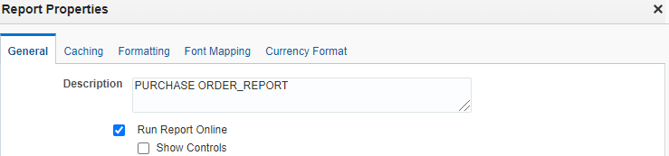
After disable

We can’t view refresh,parameter,view report.

- Allow sharing report links:
Enables users to display the URL for the current report.

Before Disable.
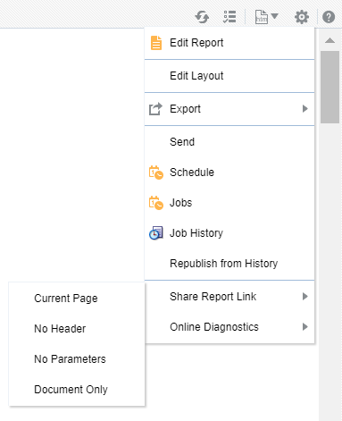

After disable:

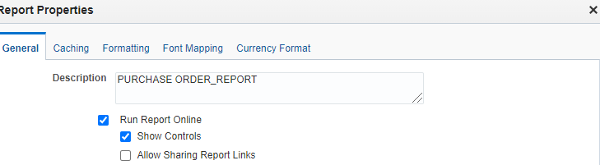
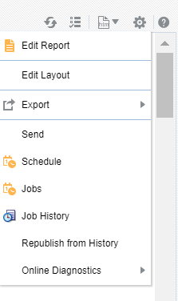
We can’t view Share report link option in settings.

- Open links in new window:
Enable:If we created link in report, it will opens in new window.
Disable:If we created link in report, it will opens in same window page.

- Auto run:
Before enable:
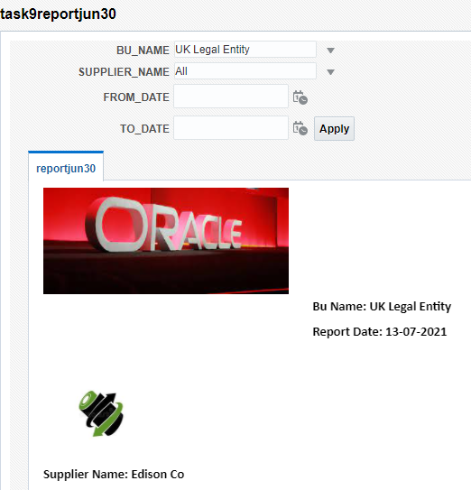

After enable:
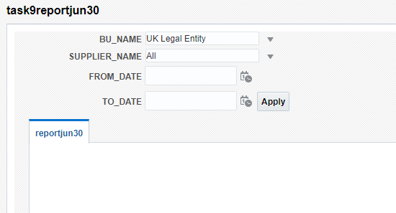
When we disable auto report it will not generate automatically until we click apply.

- Job priority:
Schedule the report to run in priority wise.
- Critical: first highest priority.
- Normal :second highest priority.
- Low :third highest priority.

- Report is Controlled by External Application Users cannot run or schedule report from catalog, can view history:
When external application integrated with BI publisher we can not view or run report in catalog. Report run by BI publisher stored in history table.If we want to view that completed report go to report job history page.

- Enterprise Scheduler Job Package Name and Enterprise Scheduler Job Definition Name: Both used for oracle fusion application implementation.

- Catching:
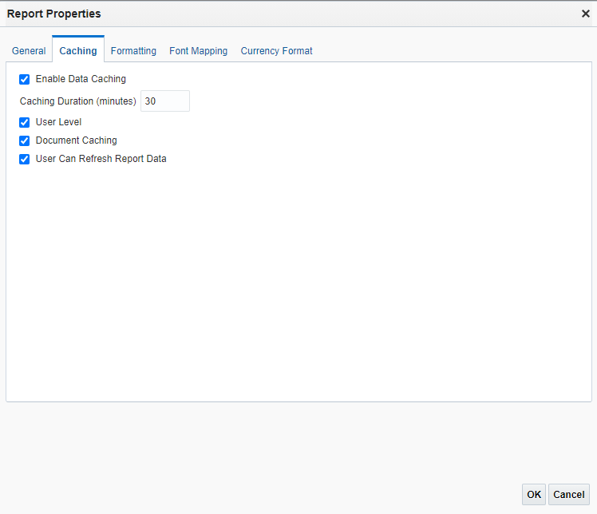

- Enable data catching:(Default: not enabled)
Data generated in online stored in cache when we run the same report (with same parameter) it will not regenerate data from source. It will take it from cache.
Caching Duration (Minutes): cache hold data for a specific time mentioned here.

- User Level:(default:30 min)
Separate cache for each user.

- Document cache: (default:enabled)
Cache report document.When user view report in online it stored in cache,when another user view the same document(with same parameter) in same online viewer it will take it from cache(user who viewed first) and it will not regenerate from source.cache holds data according to caching duration.

- User Can Refresh Report Data:(default: not enabled)
User clicks refresh in report viewer,BI publisher generate a fresh data set for the report.
FORMATTING:
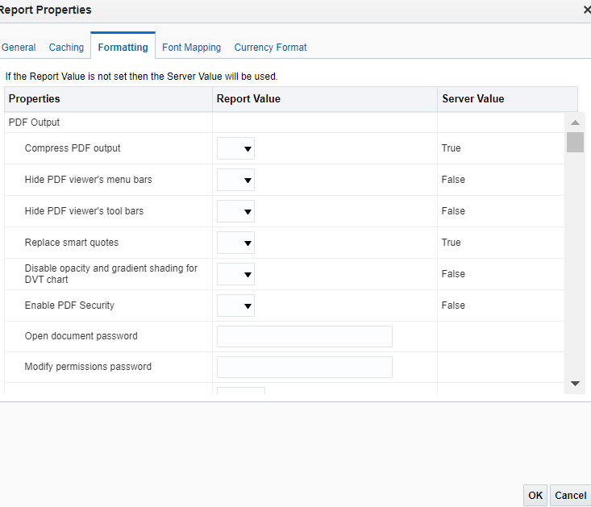

- Compress PDF output:(default:true)
Compress the output PDF file(downloaded).
TRUE:(default)- 16KB
FALSE: 40KB

- Hide PDF viewer's menu bars: Default: false
Hide menu bar(export -> PDF) in standalone Acrobat Reader application outside of the browser.
FALSE:
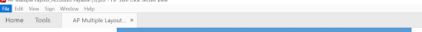
TRUE:
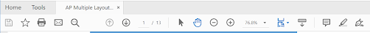

- Hide PDF viewer's tool bars(Default: false)
It will hide the toolbar option when document is active.
- Replace smart quotes:Default: true
Curly quotes are not replaced by straight quotes in PDF output.
- Enable PDF Security:Default: false
The output PDF file is encrypted.
Properties under enable PDF security:
- Open document password
- Modify permissions password
- Encryption Level
6.Open document password:Default: N/A
Password is required to open this document file.
7.Modify permissions password:Default: N/A
password enables users to override the security setting.
9.Encryption level: Default: 2 - high
The encryption level for the output PDF file. The possible values are:
- 0: Low (40-bit RC4, Acrobat 3.0 or later)
- 1: Medium (128-bit RC4, Acrobat 5.0 or later)
- 2: High (128-bit AES, Acrobat 7.0 or later)
When Encryption level is set to 0, you can also set the following properties:
- Disable printing
- Disable document modification.
- Disable context copying, extraction, and accessibility
- Disable adding or changing comments and form fields.
When Encryption level is set to 1 or higher, the following properties are available
- Enable text access for screen readers
- Enable copying of text, images, and other content
- Allowed change level
- 0: none
- 1: Allows inserting, deleting, and rotating pages
- 2: Allows filling in form fields and signing
- 3: Allows commenting, filling in form fields, and signing
- 4: Allows all changes except extracting page.
- Allowed printing level
- 0: None
- 1: Low resolution (150 dpi)
- 2: High resolution

PDF Output Properties:

Generate the type of PDF files you want by setting available output properties.

Compress PDF output:
Specify "true" or "false" to control compression of the output PDF file.
Hide PDF viewer's menu bars:
Specify "true" to hide the viewer application's menu bar when the document is active. The menu bar option is only effective when using the Export button, which displays the output in a standalone Acrobat Reader application outside of the browser.
Hide PDF viewer's tool bars:
Specify "true" to hide the viewer application's toolbar when the document is active.
Replace smart quotes:
Specify "false" if you don't want curly quotes replaced with straight quotes in the PDF output.
Disable opacity and gradient shading for DVT chart:
Specify "true" if you don't want opacity and gradient shading for the PDF output. This reduces the size of the Post-script file.
Enable PDF Security:
Specify "true” if you want to encrypt the PDF output. You can then also specify the following properties:
        - Open document password
        - Modify permissions password
        - Encryption Level
Open document password:
When you set the Encryption level to Low, Medium, or High, the password must contain only Latin-1 characters and shouldn't be more than 32 bytes long.
When you set the Encryption level to Highest, if your password exceeds 127 bytes, only the first 127 bytes of the password are used for authentication.
This password is required for opening the document. It enables users to open the document only. This property is enabled only when "Enable PDF Security" is set to "true".
Modify permissions password:
This password enables users to override the security setting. This property is effective only when "Enable PDF Security" is set to "true".
Encryption level:
Specify the encryption level for the output PDF file. The possible values are:
0: Low (40-bit RC4, Acrobat 3.0 or later)
1: Medium (128-bit RC4, Acrobat 5.0 or later)
2: High (128-bit AES, Acrobat 7.0 or later)
2: Highest (256-bit AES, Acrobat X (10) or later)
Disable document modification:
Permission available when "Encryption level" is set to 0. When set to "true", the PDF file cannot be edited.
Disable printing:
Permission available when "Encryption level" is set to 0. When set to "true", printing is disabled for the PDF file.
Disable adding or changing comments and form fields:
Permission available when "Encryption level" is set to 0. When set to "true", the ability to add or change comments and form fields is disabled.
Disable context copying, extraction, and accessibility:
Permission available when "Encryption level" is set to 0. When set to "true", the context copying, extraction, and accessibility features are disabled.
Enable text access for screen readers:
Permission available when "Encryption level" is set to 1 or higher. When set to "true", text access for screen reader devices is enabled.
Allowed printing level:
Permission available when "Encryption level" is set to 1 or higher. Valid values are:
0: None
1: Low resolution (150 dpi)
2: High resolution
PDF Navigation Panel Initial View:
Controls the navigation panel view presented when a user first opens a PDF report. The following options are supported:
- Panels Collapsed - displays the PDF document with the navigation panel collapsed.
- Bookmarks Open (default) - displays the bookmark links for easy navigation.
- Pages Open - displays a clickable thumbnail view of each page of the PDF.

HTML FORMATTING:
Show header
It suppress the template header in HTML output when set to false.
Show footer
It suppress the template footer in HTML output when set to false.
Replace smart quotes
Set to "false" if you don't want curly quotes replaced with straight quotes in the HTML output.
Character set
It Specify the output HTML character set. (EX:UTF-8)

Make HTML Output accessible
Set to "true" to make the HTML output accessible.

Use percentage width for table columns
It is useful if the browser display tables with extremely wide columns. Setting this property to true improves the readability of the tables.
View Paginated
When you set this property to true, HTML output will render in the report viewer with pagination features. These features include:
- Generated table of contents
- Navigation links at the top and bottom of the page
- Ability to skip to a specific page within the HTML document
- Search for strings within the HTML document using the browser's search capability
- Zoom in and out on the HTML document using the browser's zoom capability
Note that these features are supported for online viewing through the report viewer only.

Reduce Padding in Table-cell
When we set true to this property, it displayed without padding, which maximizes the page space available for text.

Embed images and charts in HTML for offline viewing
When we set true, charts and images are embedded in the HTML output, We can view in offline.
Use SVG for Charts
- When we set this property to true, charts display as a SVG (Scalable Vector Graphic) to provide a higher resolution in the HTML output.
- Otherwise, charts display as a raster image.
Keep original table width
When we set true to this property, the original width of the table is maintained.
HTML and CSS embedding
This property consists of embedded css in html header,
External css file,embedded css in html element

Enable horizontal scrollbar automatically for html table
When you set this property to true, a horizontal scroll bar is added to a table
Enable html table column size auto adjust
When we set true to this property, column widths in a table are automatically adjusted to the size of the browser window.

EXCEL 2007 Output
Show grid lines
If we set true, it shows the excel table grid lines in the report output.
Page break as a new sheet
When we set true to this property, it generates a new sheet in the Excel workbook.
Minimum column width
- When the column width is less than the specified minimum and it contains no data, the column is merged with the preceding column.
- The value must be set in points. The valid range for this property is 0.5 to 20 points.

Minimum row height
- When the row height is less than the specified minimum and it contains no data, the row is removed.
- The value must be set in points.
- The valid range for this property is 0.001 to 5 points.

Keep values in same column
When we set true, it minimize column merging
Open password
In this property to specify the password that the users must provide to open any XLS output file.
Table Auto Layout
- Here we Specify a conversion ratio in points and a maximum length in points, Example 6.5,150
- For this property "Keep values in same column" must be set to True.
- It expands the table column width to fit the contents.
- The column width is expanded based on the character count and conversion ratio up to the maximum specification.

ETEXT OUTPUT
Add UTF-8 BOM Signature
When set to true, the Etext output is in UTF-8 Unicode with BOM(BYTE ORDER MARK) format.

FONT MAPPING
You can map base fonts in RTF or PDF templates to the target fonts to be used in the published document. Font mapping is performed only for PDF PowerPoint output.

Types of Font Mappings:

- RTF Templates - for mapping fonts from RTF templates and XSL-FO templates to PDF and PowerPoint output fonts.
- PDF Templates - for mapping fonts from PDF templates to different PDF output fonts.

Make Fonts Available to Publisher:

Publisher provides a set of Type1 fonts and a set of TrueType fonts.

You can select any of the predefined fonts as a target font with no additional setup required.

The predefined fonts are located in <oracle_home>/oracle_common/internal/ fonts. If you want to map to another font, then you must place the font in this directory to make it available to Publisher at runtime. If the environment is clustered, then you must place the font on every server.

Set Font Mapping at the Site Level or Report Level:

A font mapping can be defined at the site level or the report level.

Use the following settings to set the font mapping:

To set a mapping at the site level, select the Font Mappings link from the Admin page.
To set a mapping at the report level, select the Configuration link for the report, then select the Font Mappings tab. These settings apply to the selected report only.
The report-level settings take precedence over the site-level settings.

Create a Font Mapping:
From the Admin page, under Runtime Configuration, select Font Mappings.

To create a Font Mapping:

Under RTF Templates or PDF Templates, select Add Font Mapping.
Enter the following on the Add Font Mapping page:
- Base Font - enter the font family that is mapped to a new font. Example: Arial
- Select the Style: Normal or Italic (Not applicable to PDF Template font mappings)
- Select the Weight: Normal or Bold (Not applicable to PDF Template font mappings)
- Select the Target Font Type: Type 1 or TrueType
- Enter the Target Font
If you selected TrueType, then you can enter a specific numbered font in the collection. Enter the TrueType Collection (TTC) Number of the desired font.
For a list of the predefined fonts, see Publisher's Predefined Fonts.

NOTE: we can also include new barcode fonts, with the existing Barcode fonts.

CURRENCY FORMATTING:

While designing XML Publisher reports, many a times we need to play with numbers and change their formats as part of the client’s requirements. Here is a brief explanation of couple of techniques that should be used while doing any number format change in XML Publisher.
XML Publisher supports two methods for specifying the number format:
- Oracle’s format-number function
- Microsoft Word’s Native number format mask
Now…before going into details please remember few things like:
- To use the Oracle format mask or the Microsoft format mask, the numbers in your data source (ex XML File) must be in a raw format, with no formatting applied.
- Use only one of these methods. If the number format mask is specified using both methods, the data will be formatted twice and it may cause unexpected behavior.
- If you are designing a template to be translatable, using currency in the Microsoft format mask is not recommended unless you want the data reported in the same currency for all translations. Using the MS format mask sets the currency in the template so that it cannot be updated at runtime.

Using the Oracle Format Mask:
To apply the Oracle format mask to a form field:
1. Open the Form Field Options dialog box for the placeholder field.
2. Set the Type to “Regular text”.
3. In the Form Field Help Text field, enter the mask definition according to the following example:
<?format-number:fieldname;’999G999D99′?>
Where fieldname is the XML tag name of the data element you are formatting and 999G999D99 is the mask definition.
Symbol | Meaning
0 | Digit. Each explicitly set 0 will appear, if no other number occupies the position. Format mask: 00.0000 (Ex: Change 1.234 to 01.2340)
9 | Digit. Returns value with the specified number of digits with a leading space if positive or a leading minus if negative. Leading zeros are blank, except for a zero value, which returns a zero for the integer part of the fixed-point number. Format mask: 99.9999 (Ex: Change 1.234 to 1.234)
C | Returns the ISO currency symbol in the specified position.
D | Determines the placement of the decimal separator. The decimal separator symbol used will be determined at runtime based on template locale. Format mask: 9G999D99 (Ex: Change 1234.56 to 1,234.56( For English locale:) or to 1.234,56 (For German locale))
EEEE | Returns a value in scientific notation.
G | Determines the placement of the grouping (thousands) separator. The grouping separator symbol used will be determined at runtime based on template locale. Format mask: 9G999D99 (Ex: Change 1234.56 to 1,234.56( For English locale:) or to 1.234,56 (For German locale))
L | Returns the local currency symbol in the specified position.
MI | Displays negative value with a trailing “-“.
PR | Displays negative value enclosed by <>
PT | Displays negative value enclosed by ()
S (before number) | Displays positive value with a leading “+” and negative values with a leading “-“
S (after number) | Displays positive value with a trailing “+” and negative value with a trailing “-“

Using the Microsoft Number Format Mask:
To format numeric values, use Microsoft Word’s field formatting features available from the Text Form Field Options dialog box. The following graphic displays an example:
To apply a number format to a form field:
- Go into the Word Properties for the field.
- Change the Type drop-down box to Number (it defaults in as Regular Text)
- From the Number format drop-down box choose the format you want.
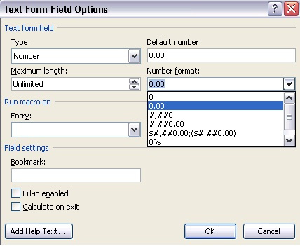

Native XSL format-number function:
You can also use the native XSL format-number function to format numbers. The native XSL format-number function takes the basic format:
format-number(number,format,[decimalformat])
Where:
number (Required) – Specifies the number to be formatted.
Format (Required) – Specifies the format pattern. Use the following characters to specify the pattern:
Symbol | Meaning
# | Denotes a digit. Example: ####
0 | Denotes leading and following zeros. Example: 0000.00
. | The position of the decimal point Example: ###.##
, | The group separator for thousands. Example: ###,###.##
% | Displays the number as a percentage. Example: ##%
; | Pattern separator. The first pattern will be used for  positive numbers and the second for negative numbers

Decimal format (Optional) – For more information on the decimal format please consult any basic XSLT manual.

Currency Formatting:
This is another feature of XML Publisher that enables you to define specific currency format masks to apply to your published data at runtime.
To utilize currency formatting, you must:
1. Define your currency formats in XML Publisher’s Administration interface.
2. Assign the Currency Format Set as a configuration property at the desired level (site, data definition, or template).
3. Enter the format-currency command in your RTF template to apply the format to the field at runtime.
To use the format-currency command:
In the form field dialog of the field you want to format, enter the following syntax:
<?format-currency:ELEMENT_NAME;’currency-format-code’?>
For example:
<?format-currency:BALACE_TOTAL;’USD’?>
The currency code must correspond to a currency format that is defined in the Currency Format Set to be used with this report. The Currency Format Set can be specified at the site level, data definition level, or template level.

